4. Dad, what are you doing now?

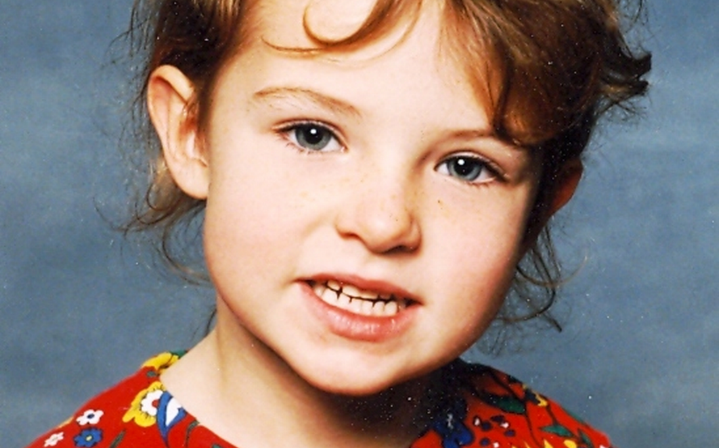
This morning as I was getting ready for school, my little daughter kept asking me, "What are you doing now, dad?" After answering her about ten times in ten different ways, in exasperation I started to tickle her saying, "Tickling my favourite princess!" She then laughed, and said, "No, Dad, you are getting ready for school!"
No activity was too small or too insignificant to matter to her. In my education community and church I may be one person of no real prominence or significance, but to her I am the pivot of her world. In my classroom later in the day I realize I too am my heavenly Father's son - and I too should be asking throughout the day, "What are you doing, Dad?" Nothing of my day is too small for God, my Abba Father, and my life ought to be centred on the things my eternal Father is doing.
I am not going to miss out on what Abba Father is doing about me today. Every email and encounter with another person, and every “interruption” and seeming setback, is foreseen and part of His providential will for me.

Luke 10:21 "I praise you, Father, Lord of heaven and earth, because you have hidden these things from the wise and learned, and revealed them to little children. Yes, Father, for this was your good pleasure.

